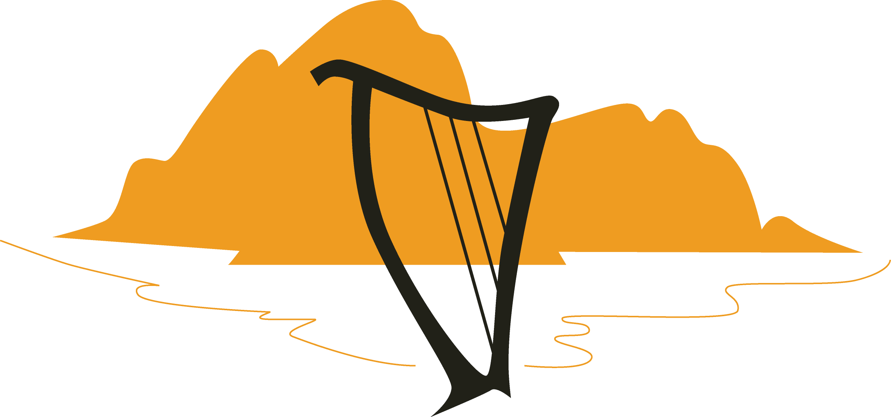

Absolute
Beginners
Workshop

Harps North West

Registered charity number 1093441 www.harpsnorthwest.org.uk

Saturday 20th November 2021
13.30 to 16.30
(13.15 arrival)

Orton Market Hall - CA10 3RU

Tutor: Mary Dunsford

Harps North West promotes the playing,
learning and enjoyment of the harp.

Tutor: Mary Dunsford
Mary has been playing the harp for 30 years, having started at the age of 8. She studied Music at Lancaster University and then completed a Post Graduate Certificate in Education. Mary teaches adults and children in the North West, and has led a variety of workshops for Harps North West. In 2010 Mary published her first book on learning the harp for adult beginners, "The Theory Handbook", to great acclaim. Mary has performed in all the top concert venues across the country, including the Royal Albert Hall, Sheffield Hallam FM Arena, and Sage Gateshead, with the National Festival Orchestra.

About this Workshop. These workshops are for absolute beginners and harps will be provided.

No previous experience is necessary. Music will be handed out on the day. Students may bring a recording device if they wish.

Please bring your own refreshments.

Cost: £25.00

How to book your place: Please complete and return the booking form as soon as possible. Places are on a ‘first come’ basis so please book to be sure of your place.

Venue:
Orton Market Hall
CA10 3RU

Application form

I wish to attend: Absolute Beginners Workshop
on Saturday 20th November
My name: ……………………………………………………………………………………….
Address:…………………………………………………………………….……………………
Postcode……………………Telephone number……………….…………………...
E-mail…………………………………………………………………….….
Age, if under 18 …………………………………
Previous musical experience (for our info)

…………………………………………………………………………………………………. .……
Where did you hear about the course? …………………………………………..

Workshop Fee: £25.00
The fee includes a £5 non-returnable deposit for HNW’s administration costs if you wish to cancel.
Direct bank payment include your name followed by BW to:
HSBC. Sort code: 40-16-22. Account 81806521
Alternatively please make cheque payable to Harps North
West.

Return this form by email to Mandy on events@harpsnorthwest.org.uk

There will be the opportunity to hire a harp at the end of the session. £70 per quarter. £50 deposit plus membership of HNW (Adults - £20. Under 18 - £10)

