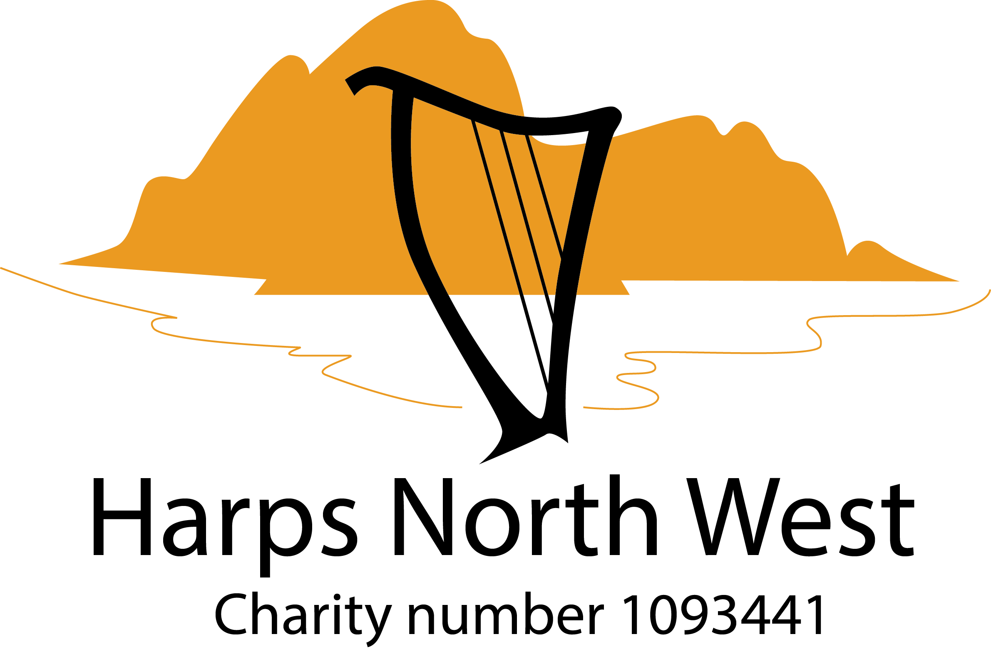

Absolute Beginners Workshop for the Harp

Saturday 12th March 2022 - 13.45 to 16.30
Slyne with Hest Church Hall, LA2 6JG
Cost: £25

About this Workshop
These workshops are for absolute beginners. Harps and music stands will be provided.
No previous experience is necessary. Music will be handed out on the day. Students may bring a recording device if they wish. Light refreshment will be provided.

Tutor: Mary Dunsford
Mary has been playing the harp for 30 years, having started at the age of 8. She studied music at Lancaster University and then completed a Post Graduate Certificate in Education. Mary teaches adults and children in the North West, and has led a variety of workshops for Harps North West. In 2010 Mary published her first book on learning the harp for adult beginners, "The Theory Handbook", to great acclaim. Mary has performed in all the top concert venues across the country, including the Royal Albert Hall, Sheffield Hallam FM Arena, The Sage Gateshead, and with the National Festival Orchestra.
Harp hire
There will be the opportunity to hire a harp at the end of the session, dependent on demand. £70 per quarter. £50 deposit plus membership of HNW (Adults - £20. Under 18 - £10)

Booking
Please contact Mandy on events@harpsnorthwest.org.uk for an application form or complete the application form below/attached and return to Mandy on the email address given above.
Application form - I wish to attend the
Absolute Beginners Workshop on Sat 12th March at Slyne with Hest Church Hall, LA2 6JG, from 13:45 to 16:30

Name of workshop attendee:

Address:

Email:

Phone contact:

Age if under 18 (Adults must accompany U18s):

For U18s , name of accompanying adult:

Previous musical experience (for our info only):

Workshop fee: £25
The fee includes a £5 non-returnable deposit for HNW’s administration costs, in case of cancellation.

Please pay by bank transfer of possible.
Bank: HSBC
Sort Code: 40-16-22
Account No: 81806521

Use reference: Your surname followed by ABW

Or post a cheque made out to Harps North West to:
Administrator, Harps North West, 16 Lowther Street, Penrith, CA11 7UW

