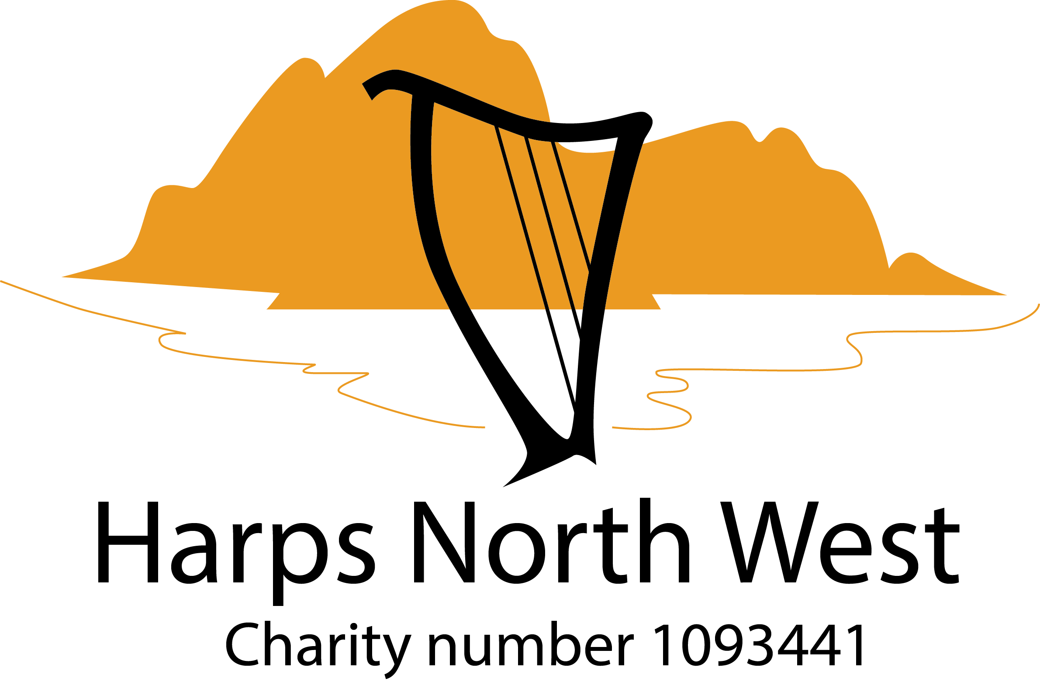

Absolute Beginners’ Workshop for the Harp

Sunday 25th February 2024 - 13.30 to 16.00 (arrive 13:15)
Grizebeck Community Hall, LA17 7XH
Cost: £30

About this Workshop
This workshop is for absolute beginners. Harps and music stands will be provided. No previous experience is necessary. Music will be handed out on the day. Students may bring a recording device if they wish. Light refreshment will be provided.

Tutor: Mary Dunsford
Mary has been playing the harp for 30 years, having started at the age of 8. She studied music at Lancaster University and then completed a Post Graduate Certificate in Education. Mary teaches adults and children in the North West, and has led a variety of workshops for Harps North West and other harp groups. In 2010 Mary published her first book on learning the harp for adult beginners, "The Theory Handbook", to great acclaim. Mary has performed in top concert venues across the country, including the Royal Albert Hall, Sheffield Hallam FM Arena, The Sage Gateshead, and with the National Festival Orchestra.
Harp hire
There will be the opportunity to hire a harp at the end of the session, dependent on demand. £80 per quarter. £50 deposit plus membership of HNW (Adults - £20. Under 18 - £10)

Post Beginner Personal Best series
Carry on your harp journey with this package of tuition videos led by Mary and accompanying sheet music. Cost £30 for those who have taken part in a beginners’ session and those hiring a harp from HNW.

Booking
Please contact Gill on events@harpsnorthwest.org.uk for an application form or complete the application form below/attached and return to Gill on the email address given above.

APPLICATION FORM
I wish to attend the Absolute Beginners Workshop on Sunday 25th February at Grizebeck Memorial Hall, LA17 7XH, from 13:30 to 16:00. Arrive 13:15

Name of workshop attendee:

Address:

Email:

Phone contact:

Age if under 18 (Adults must accompany U18s):

For U18s , name of accompanying adult:

Previous musical experience (for our info only):

Please let us know of any accessibility needs you may have:

Workshop fee: £30
The fee includes a £5 non-returnable deposit for HNW’s administration costs, in case of cancellation.

Please pay by bank transfer of possible.
Harps North West
Bank: HSBC
Sort Code: 40-16-22
Account No: 81806521

Use reference: Your surname followed by ABW
Or post a cheque made out to Harps North West to: Administrator, Harps North West, 16 Lowther Street, Penrith, CA11 7UW

